DESIGN AND ANALYSIS OF ALGORITHM

LAB EXPERIMENT -7 NAME: Ragavendar
ROLL NO: CH.SC.U4CSE24260

1. JOB SCHEDULLING
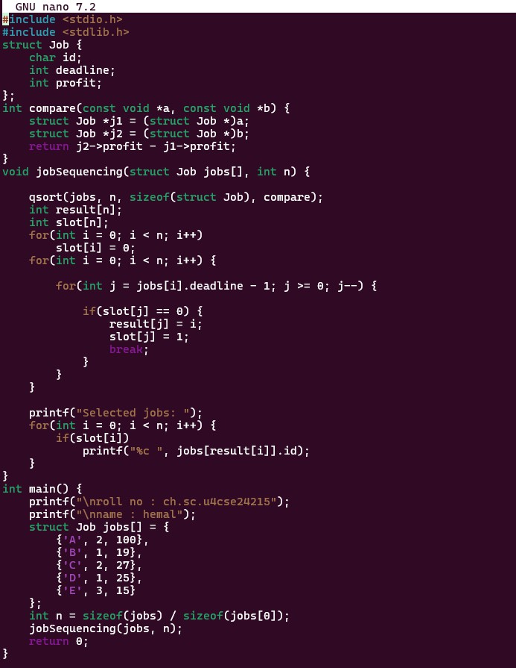
CODE:

OUTPUT:
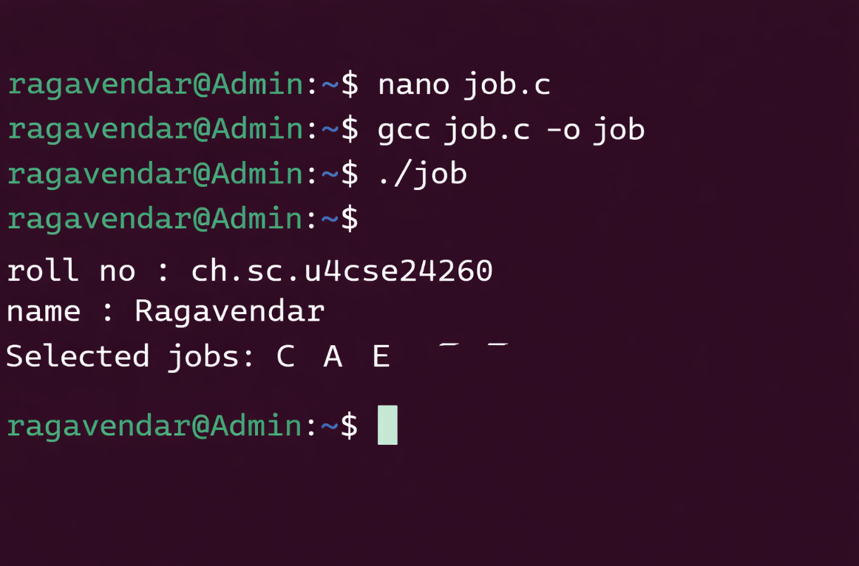

INTERPRETATION:
Job Scheduling with deadlines is a greedy algorithm used to schedule jobs in a way that maximizes total profit while completing each job before its deadline.
It works by sorting jobs in decreasing order of profit and assigning them to the latest available time slot before their deadline.

